Heating Water
Aim:
- To show how the temperature of water changes whilst being heated over time
- To accurately draw a line graph
Materials:

- 250mL beaker
- Measuring cylinder
- Thermometer
- Stop watch
- Heat proof mat
- Bunsen Burner
- Matches
- Tripod
- Gauze mat
- Retort stand
- Bosshead and Clamp

Method:
- Using a measuring cylinder, measure 100mL of water and pour into the beaker
- Set up the equipment shown in the diagram below (make sure the thermometer is not touching the bottom of the beaker)
- Measure and record the initial temperature of the water at 0 minutes
- Light the Bunsen burner – yellow flame (be sure that the Bunsen burner is not under the beaker)
- Change the flame to blue and place the Bunsen burner under the beaker while another person starts the stop watch
- Measure and record the temperature of the water every minute for 10 minutes

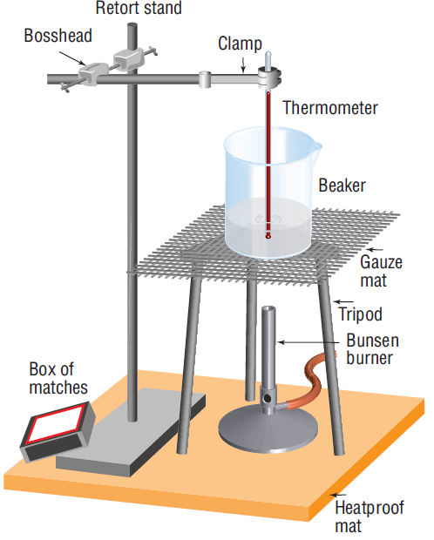
Results:
- Complete the following table
Time (min) | Temperature (◦C) | Time (min) | Temperature (◦C)
1 |  | 6
2 |  | 7
3 |  | 8
4 |  | 9
5 |  | 10

- Draw a line graph displaying the change of water temperature over time

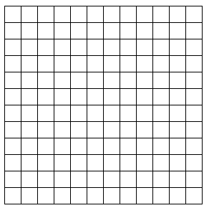
Temperature (◦C)

Time (minutes)
Discussion:
- What are we measuring in this experiment
- Identify if the data collected is qualitative or quantitative
- Describe how the temperature of the water changes over time
- Use your graph to estimate the water temperature 4.5 minutes after heating started
- Predict the temperature that the water would have reached 11 minutes after heating started
Conclusion: Write one sentence relating back to your aim

