Balanced and Unbalanced Forces
Label the forces acting on the following objects and state whether the forces are balanced or unbalanced
(a) Stationary objects

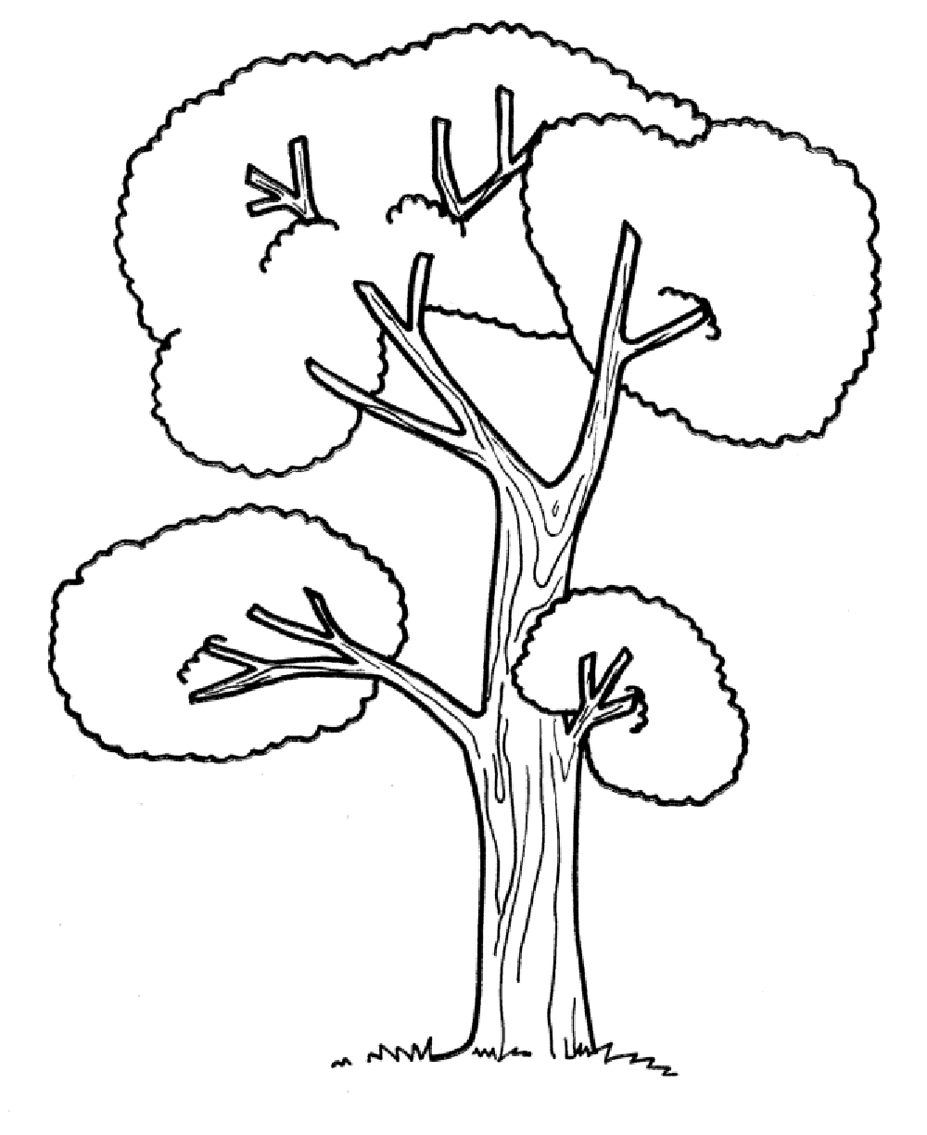

(b) Objects accelerating
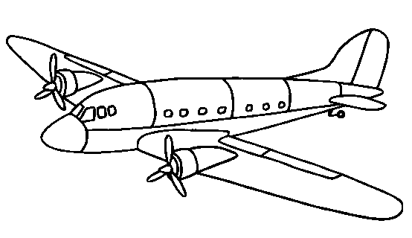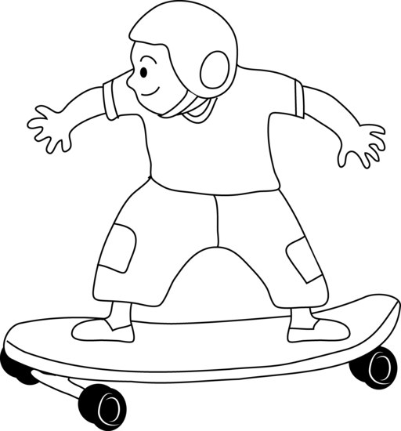

(c) Objects at a constant speed
