Friction and Mass
Aim: To investigate how increasing mass affects the size of friction

Hypothesis:
________________________________________________________________________________________________________________________________
Materials:
• wooden block with hook
• spring balance or force sensor
• 200 g masses
Method:
1 Place the wooden block on a bench top.
2 Attach the spring balance to the block of wood as shown in Figure 7.2.12.
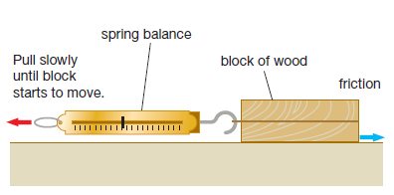
3 Measure the size of the force needed to keep the block moving at a constant speed. This is equal to the force of friction. Record this in your results table.
4 Repeat step 3 twice and record the results.
5 Add a 200 g mass on top of the block of wood. Measure the friction between the block and the bench top three times and add these results to the table.
6 Repeat the friction measurements for 400, 600, 800 and 1000 g (1 kg) masses on the block, recording three results for each test.

Results:
Table 1: Lino surface
Object moving | Friction force measured (N) |  |  | Average friction (N)
 | Trial 1 | Trial 2 | Trial 3
Wooden block
Wooden block + 100g
Wooden block + 200g
Wooden block + 300g
Wooden block + 400g
Wooden block + 500g

Table 2: Carpet surface
Object moving | Friction force measured (N) |  |  | Average friction (N)
 | Trial 1 | Trial 2 | Trial 3
Wooden block
Wooden block + 100g
Wooden block + 200g
Wooden block + 300g
Wooden block + 400g
Wooden block + 500g

Draw a line graph for the results: Mass (x axis), Average Friction (y axis)
Discussion:
- State the following variables:
- Controlled
- Independent
- Dependent

- Describe what happened to the size of the force of friction as the mass on the wooden block increased.

- Describe the difference in force needed to move the block on the carpet and then on the lino. Why do you think there was a difference?

Conclusion:

