Lab Safety
You will usually find a set of lab rules in a science lab. They are there for your safety! The drawing below shows a lab where there are no safety rules.

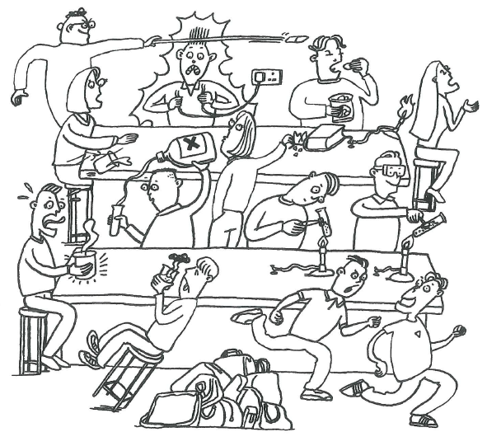
- Write down a list of all the things going wrong in this lab
(circle these in the picture)
- For each of your answers, write a safety rule
- Design a poster for your lab class using the assessment sheet on the next page. This will be your first assessment task for Science.

