Reducing Friction
Aim: To reduce the force of friction between a lego car and a block of wood.
Hypothesis:
Which material will have the most friction: ______________________
Which material will have the least friction: ______________________
Will you expect the same results for sandpaper for both sides of your lego car? Why? ____________________________________________
Results:
Surface | Angle (◦)
 | Lego Side | Wheel side
Wood | 15◦ | 2◦
Grip mat | 35◦ | 5◦
Sandpaper | 60◦ | 7◦
Material | 35◦ | 4◦
Carpet | 25◦ | 8◦
Wax paper | 10◦ | 2◦
Transparent sheet | 23◦ | 3◦

Draw a bar graph showing the results from the table above.

Discussion:
- List the following variables:
- Controlled
(b) Independent
(c) Dependent
- Draw arrows and labels of the forces acting on the lego car
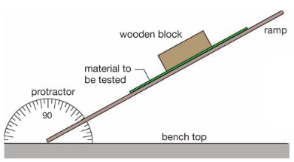
- Which surface had the most friction acting on the lego car? Explain why.
- Which surface had the least amount of friction acting on the lego car? Explain why?
- Why were your results different for lego side and wheel side of the car? Which side has the least amount of friction?

Conclusion: Summary paragraph relating friction to surface

